cs4471b/cs9549b – Software Architectures

Project: The PurplePages - Team 1

By: Chengyuan Zhang

Gary Chiu

Matthew Dudycz

Vatsal Shah

Wayne Lyu

Progress Report 1

Table of Contents

**Service Offered** **2**

**Service Requirements** **2**

**Project Plan** **2**

Chart 2

Spreadsheet 2

**Bluemix Introduction** **2**

**SOA Introduction** **3**

# Service Offered

Found in: 2_Services Offered.xlsx

# Service Requirements

Found in: 3_Services Requirements.xlsx

# Project Plan

## Chart

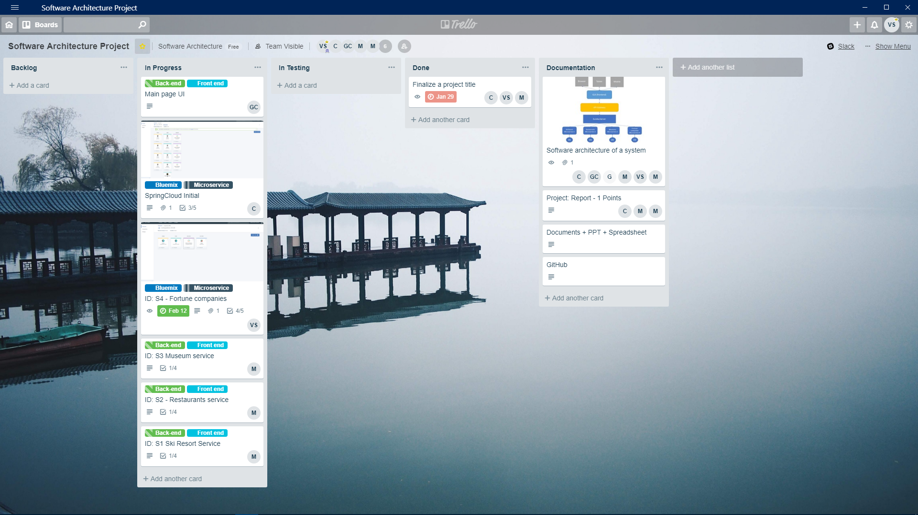

## Spreadsheet

Found in: 4_Project Plan.xlsx

# Bluemix Introduction

* In Bluemix, we can create applications and build, deploy them automatically using IBM Cloud tools.
* For the Microservice architecture, Bluemix documentation slightly touches on how to create a Microservice Software by using Toolchain.
* We have drawn some experiences from the tutorial and created a new Toolchain by leveraging Github and Delivery Pipeline. Github serves as a version control tool for our team.
* Our code is deployed on bluemix, using one instance with 256 MB memory for each service.
* Slack has been adopted in our project as the message hub. By adding channel webhook request, name and team name, any notifications from a microservice can be directly viewed in the tool.
* Spring Boot Microservice:
  + We initialized Spring Boot applications using Maven locally for three Microservices and each of them correspondings to one Cloud Foundry Application in Bluemix. After developing all the microservices locally and pushing the branch to the repository, the service on Bluemix named Continuous Delivery will detect the changes, then build and deploy the Maven project.
  + As for the Eureka Server, it is considered as the Registration Center which should be configured as the service in Bluemix. Cloud Foundry CLI is an efficient tool to config the Bluemix cloud applications, which can be useful to register a service in local command line.
  + For the Eureka clients part, the configuration should be modified and fit to the cloud server where the parameters and variables are different from the local machine. Finally, the essential part is binding to each client to the Eureka service on Bluemix.
* NodeJS Microservice:
  + We initialized the Nodejs microservice application and enabled toolchain. Moreover, installed node models and changed the code to call endpoint of a service.

# SOA Introduction

Service-oriented architecture has main components as below:

* Graphical User Interface
* API Gateway
* Eureka Server
* Microservices
  + S1: Ski resorts
  + S2: Restaurants
  + S3: Museums
  + S4: Fortune companies

